Corrugated TANDUMS:

The ADD TANDEM button works with all MASTER ESTIMATES for estimates that are tandem estimates. Tandem estimates are created by adding a new form for the same estimate, which can be done with the copy button on the estimate tab. The new master estimate will have potential other forms that are run back to back (print change only). When in order entry you will be able to select which forms make up the order – and a new master estimate will be created.

I created a new order, which simultaneously created a new order, new estimate and new job in one step.
Note, then new estimate show the FROM field with the master estimate.
That is the key to a MASTER estimate. A master tandem estimate has the FROM field blank.
The F1 will only show master estimates.

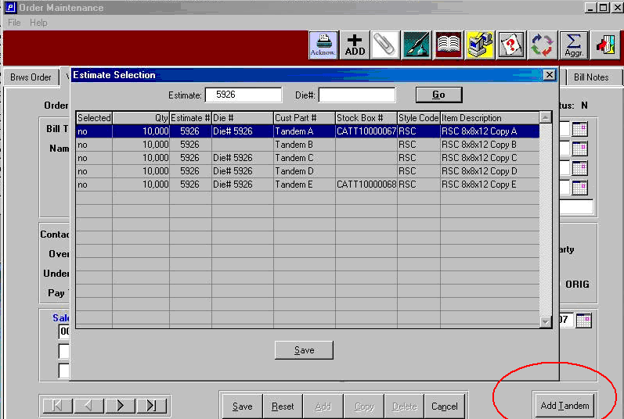

Newly created estimate from order entry. Note, the field called FROM to the right of estimate #. This shows the new estimate number followed by the original master estimate number.

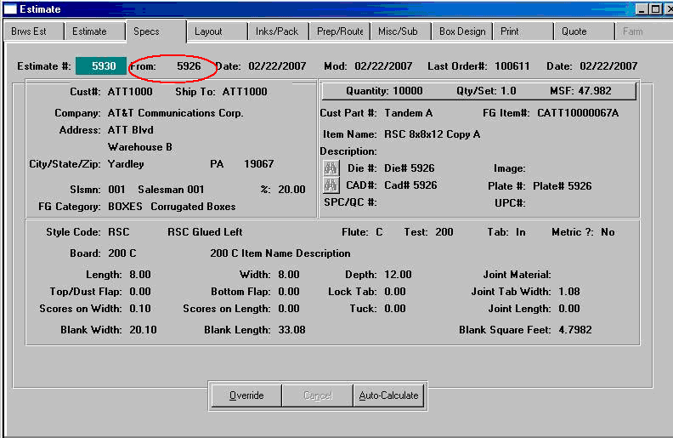

Lastly, the ADD button on the line item allows you to add new items to the new estimate, while simultaneously adding this new item to the MASTER estimate. Please note, the delete button will only delete an item from the current order and current estimate, thus preserving the original master estimate.

